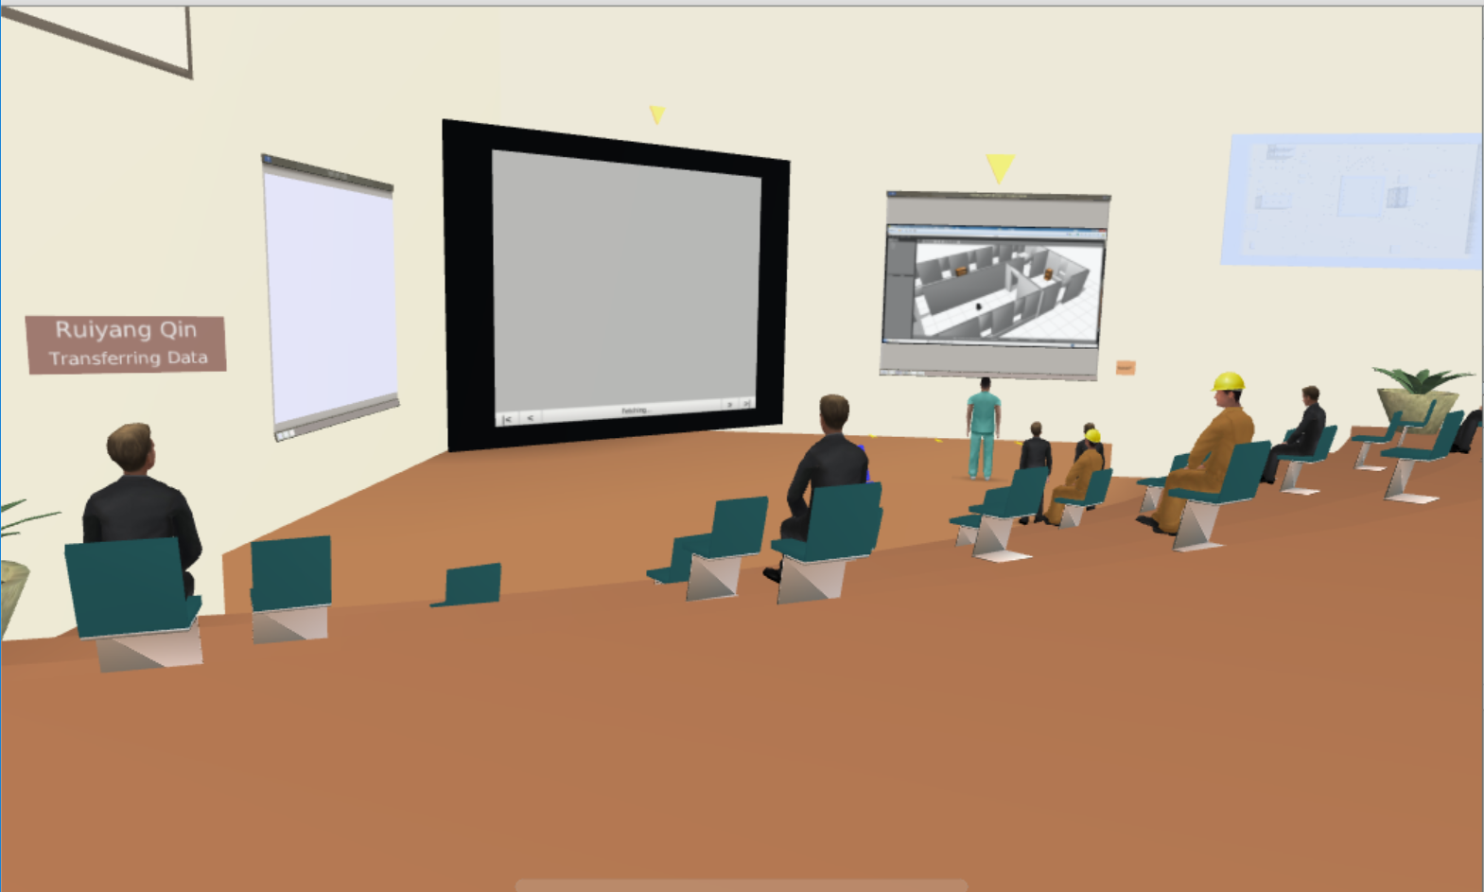

Honestly, this is my first time to know ROS, cause I used to thought that robot acting only based on programming language. ROS seems like a framework which integrates functions and languages and makes them work together efficiently. Since I don't know Linux and python, so I will not be able to read those codes. That is that one thing makes me feel bad. I’ve heard about MATLAB before but didn’t learn anything. After this lecture, I think I might do some MATLAB, at least knowing what it is.